Video Processing

A video is a sequence of images called frames.
For each video we have a frame rate which can be identified using FPS i.e. Frames per Second
Example: 30 fps means we have 30 images/frames per second
As the frame rate increases the quality of the video also increases
Total Frames = FPS * Duration

Video resolution
More the video resolution more the clarity of the image and size
Resolution = width * height
Some of the resolutions
640 x 480 (480 P) => SD quality video
1280 x 720 (720 P) => HD quality video
1920 x 1080 ( 1080 P ) => FHD
2560 x 1440 (1440 P) => 2K QUAD HD
3840 x 2160 (2160 P) => 4K

Some the use cases that we can solve using the CC camera Data:
CCTV cameras can monitor public areas like roads or campuses to identify sudden incidents such as accidents. When unusual activity is observed such as a collision, a person falling, or sudden crowd disturbance the system can immediately trigger an alert. It can automatically share the location and relevant video clip with emergency services such as police or hospitals, ensuring a faster response and potentially saving lives.
In educational institutions, CCTV footage can help ensure student safety and protect property. The system can observe unusual physical interactions, such as fighting, aggressive behavior, or vandalism. If such behavior is detected, administrators can be alerted in real time. This allows quick intervention to prevent harm, maintain discipline, and protect college property from damage.
If we are given a specific object image, such as a photo of a bag or laptop, CCTV footage can be used to identify the last time that exact object was seen in the recorded video. The system compares the given image with the objects appearing in different time frames of the footage and searches through the timeline. Once it finds matches, it determines the most recent moment when the object was visible. This allows security personnel to quickly know the exact last known time and location of the object without manually reviewing hours of video.

Experiment -1 :

Here we are extracting 20 Frames from each video
The shape of the video frame is (20,224,224,3).
20 represents the frames
224,224,3 represents the image / frame shape

Here we used the MobileNetV2 model in order to classify the video. But the MobileNetV2 is trained on ImageNet which are images. So, it won’t work well for classifying the video. For video classification we can go with CNN+RNN hybrid model or we can also go with 3D CNN.

Here we are giving 20 frames as input to the model and for each frame it produces the output Probability distribution for 1000 classes. So, the output shape will be (20,1000)

When we do np.mean() along the axis 0 we are finding the average of probability of each class and we end up with the output shape of (1000,)

We take the sum of all the 1000 values we will get the value 0.99999994 (1 approx)
We can plot the image / frames at a particular time frame t.
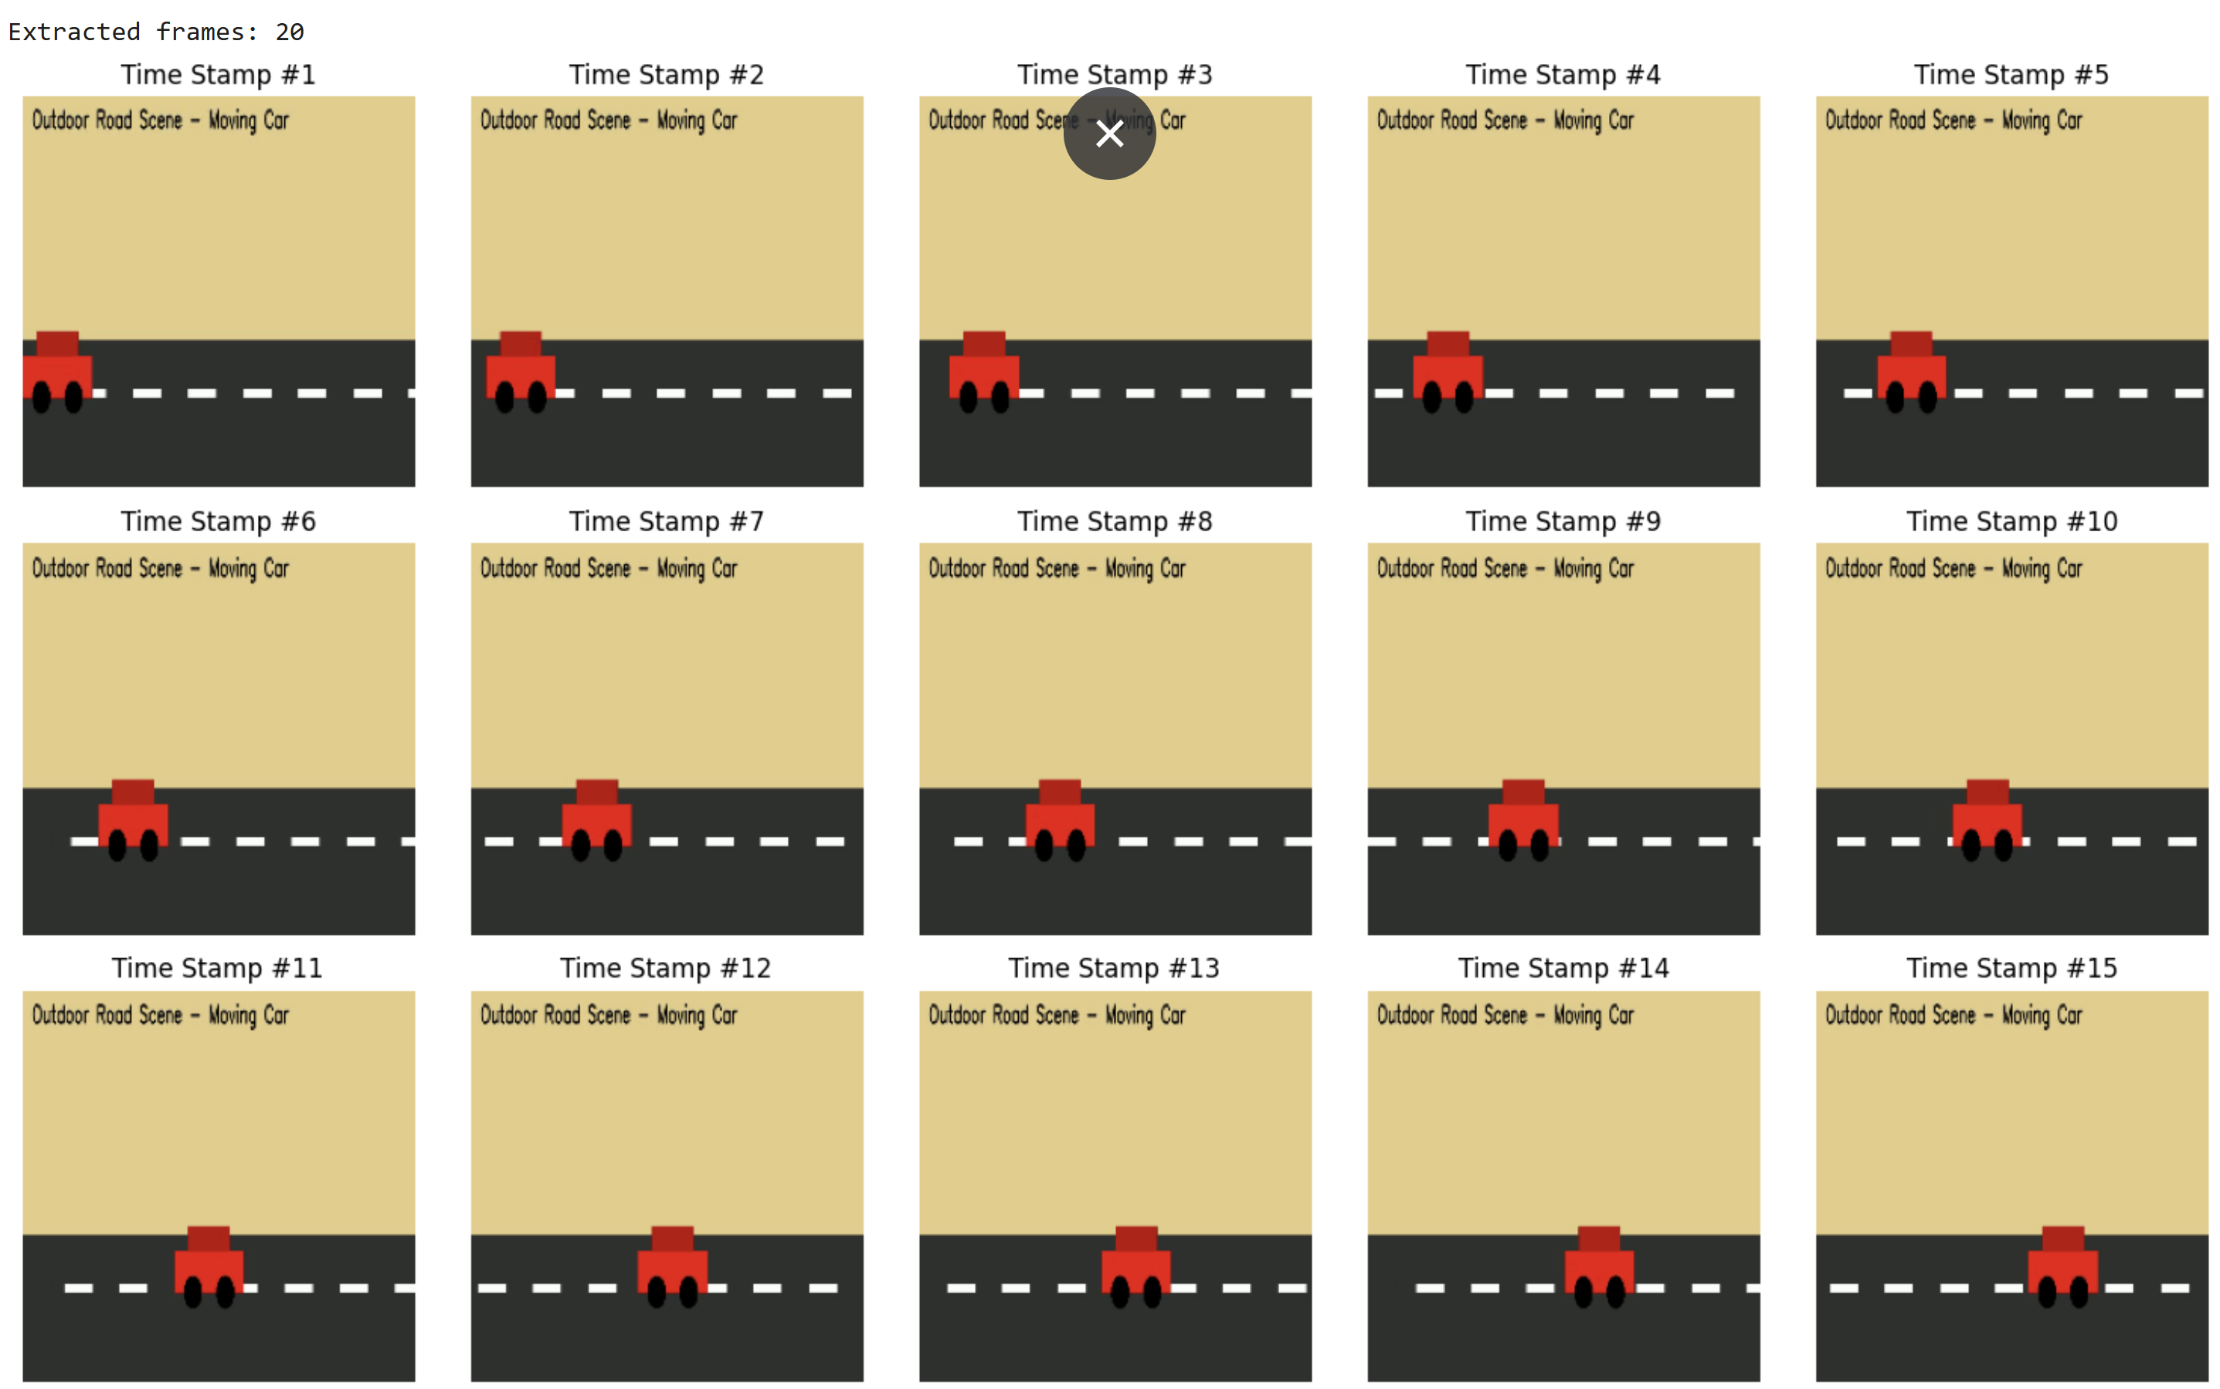

Experiment -2 :

Attribute / Method Name | Attribute / Method Name | Attribute / Method Name
cv2.VideoCapture('video_file.mp4') | A VideoCapture object | It creates a connection to the video file. This object allows us to access and read frames from the video. It does not return frame data directly, but prepares the system to retrieve video information.
cap.get(cv2.CAP_PROP_FRAME_COUNT) | A number (float) | It returns the total number of frames present in the video. This value represents how many individual images make up the entire video.
cap.get(cv2.CAP_PROP_FRAME_HEIGHT) | A number (float) | It returns the height of each frame in pixels. The value tells how many pixels exist vertically in every frame.
cap.get(cv2.CAP_PROP_FRAME_WIDTH) | A number (float) | It returns the width of each frame in pixels. The value tells how many pixels exist horizontally in every frame.
cap.get(cv2.CAP_PROP_FPS) | A number (float) | It returns the number of frames displayed per second. This value indicates how smooth the video appears during playback.
cap.read() | Two values: (ret, img) | The first value (ret) is either True or False. It indicates whether a frame was successfully read. The second value (img) is the actual image frame stored as a numerical array containing pixel information.
img.shape | A tuple of three numbers | It returns the dimensions of the image in the format (height, width, number of color channels). The first value is vertical pixels, the second is horizontal pixels, and the third usually represents color information (for example, 3 for color images).
cv2.cvtColor(img, cv2.COLOR_BGR2RGB) | A modified image array | It returns a new image with rearranged color values. The pixel data remains the same in size, but the color order is corrected for proper display.
cap.release() | No return value | It closes the video file connection and frees system resources. It does not produce any visible output.

